Stephen C. Pittman

SNHU

CS 210

6/21/24

The code is designed to read item data from a file named `Text.txt`, compute the frequency of each item, and provide a user-friendly interface for interacting with the data. It utilizes the C++ Standard Library, specifically `iostream` for input/output operations, `fstream` for file handling, `map` for storing item frequencies, and `string` for string manipulation. The program begins by defining a function `readFromFile` that reads items from `Text.txt` and updates a map with the frequency of each item. If the file cannot be opened, it prints an error message and exits the program. Similarly, the function `writeToFile` writes the frequency data to a file named `frequency.dat`, with error handling for file operations.

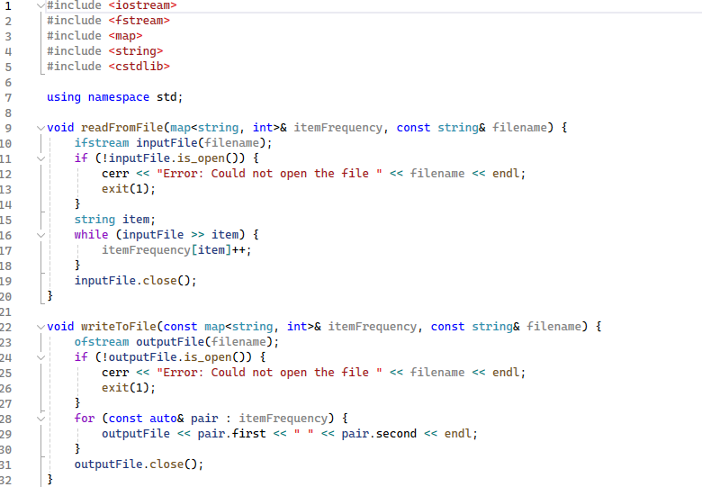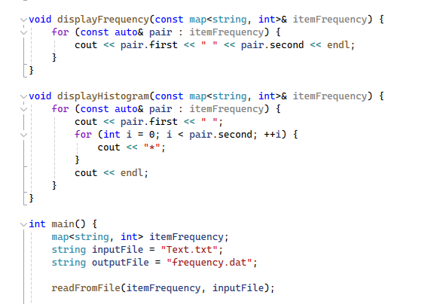

The `displayFrequency` function prints all items and their frequencies, while the `displayHistogram` function visually represents the frequencies using asterisks. In the `main` function, the program reads the item data from `Text.txt` into a map and then enters a loop that displays a menu with four options. The user can search for the frequency of a specific item, display all items with their frequencies, display a histogram of items, or exit the program. Upon exiting, the frequency data is written to `frequency.dat`. The menu allows users to interact with the data easily, providing both textual and visual representations of item frequencies, thus making the program both functional and user-friendly.

